# Coding Challenge

Total Duration: 2 Hours

Sections:

1. Python Programming & OOP (40 mins)  
2. Data Structures & Algorithms (30 mins)  
3. SQL with Python Integration (30 mins)  
4. Version Control with Git (10 mins)  
5. Bonus/Stretch Task: Unit Testing with PyUnit (10 mins)

## Section 1: Python Programming & OOP (40 mins)

Q1. Functional Coding Challenge – Movie Booking System (20 mins)  
- Show available movies (stored in a list)  
- Allow user to select movie & number of tickets  
- Calculate and show total amount (use a dictionary to store movie:price)  
- Use functions for showing movies, booking logic, and calculating amount

**SOLUTION**

movies = ["Avengers", "Inception", "The Matrix", "Parasite"]

prices = {

    "Avengers": 250,

    "Inception": 200,

    "The Matrix": 180,

    "Parasite": 150

}

def show_movies():

    print("Available Movies:")

    for i in range(len(movies)):

        name = movies[i]

        cost = prices[name]

        print(f"  {i+1}. {name} – Rs.{cost}")

def calculate_amount(movie_name, ticket_count):

    price_per_ticket = prices.get(movie_name, 0)

    return price_per_ticket * ticket_count

def book_tickets()

    show_movies()

    choice = input("Enter the movie number you want to book: ").strip()

    if not choice.isdigit():

        print("Invalid input: please enter a number.")

        return

    choice = int(choice)

    if choice < 1 or choice > len(movies):

        print("Invalid selection: that movie number does not exist.")

        return

    selected_movie = movies[choice - 1]

    qty = input(f"How many tickets for '{selected_movie}'? ").strip()

    if not qty.isdigit():

        print("Invalid input: please enter a number of tickets.")

        return

    qty = int(qty)

    if qty <= 0:

        print("Invalid quantity: you must book at least one ticket.")

        return

    total = calculate_amount(selected_movie, qty)

    print(f"You have booked {qty} ticket(s) for '{selected_movie}'.")

    print(f"Total amount: Rs.{total}")

if __name__ == "__main__":

    book_tickets()

**OUTPUT**

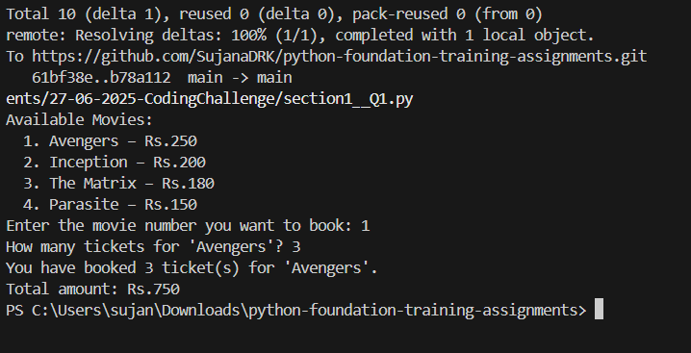

Q2. OOP Implementation – Library Management (20 mins)  
- Create classes Book, Library, and User  
- Library contains a collection of books  
- User can borrow/return/view books  
- Use class, constructor, inheritance, method overriding

**SOLUTION**

class Person:

    def __init__(self, name):

        self.name = name

    def display_info(self):

        print(f"Person: {self.name}")

class User(Person):

    def __init__(self, name):

        super().__init__(name)

        self.borrowed_books = []

    def display_info(self):

        # Method overriding

        print(f"Library User: {self.name}")

    def view_books(self, library):

        print("\nCurrent Library Collection:")

        library.list_books()

    def borrow_book(self, title, library):

        book = library.find_book(title)

        if not book:

            print(f" Book '{title}' not found.")

        elif not book.available:

            print(f" '{title}' is already checked out.")

        else:

            book.available = False

            self.borrowed_books.append(book)

            print(f" You have borrowed '{title}'.")

    def return_book(self, title, library):

        for book in self.borrowed_books:

            if book.title.lower() == title.lower():

                book.available = True

                self.borrowed_books.remove(book)

                print(f" You have returned '{title}'.")

                return

        print(f" You did not borrow '{title}'.")

class Book:

    def __init__(self, title, author):

        self.title = title

        self.author = author

        self.available = True

    def __str__(self):

        status = "Available" if self.available else "Checked out"

        return f"{self.title} by {self.author} — {status}"

class Library:

     def __init__(self):

        self.collection = []

     def add_book(self, book):

        self.collection.append(book)

     def list_books(self):

         if not self.collection:

            print("  (no books in library)")

         for book in self.collection:

            print(f"  - {book}")

     def find_book(self, title):

        for book in self.collection:

            if book.title.lower() == title.lower():

                return book

        return None

def main():

       library = Library()

       library.add_book(Book("1984", "George Orwell"))

       library.add_book(Book("Dune", "Frank Herbert"))

       library.add_book(Book("Harry Potter", "J.K. Rowling"))

       user = User("Alice")

       print("Welcome to the Library Management System")

       user.display_info()

       while True:

          print("""

Please choose an action:

  1) View all books

  2) Borrow a book

  3) Return a book

  4) Exit

""")

          choice = input("Enter choice (1–4): ").strip()

          if choice == "1":

             user.view_books(library)

          elif choice == "2":

            title = input("Enter the title you want to borrow: ").strip()

            user.borrow_book(title, library)

          elif choice == "3":

            title = input("Enter the title you want to return: ").strip()

            user.return_book(title, library)

          elif choice == "4":

            print("Goodbye!")

            break

          else:

              print("Invalid selection; please choose 1–4.")

if __name__ == "__main__":

    main()

**OUTPUT**

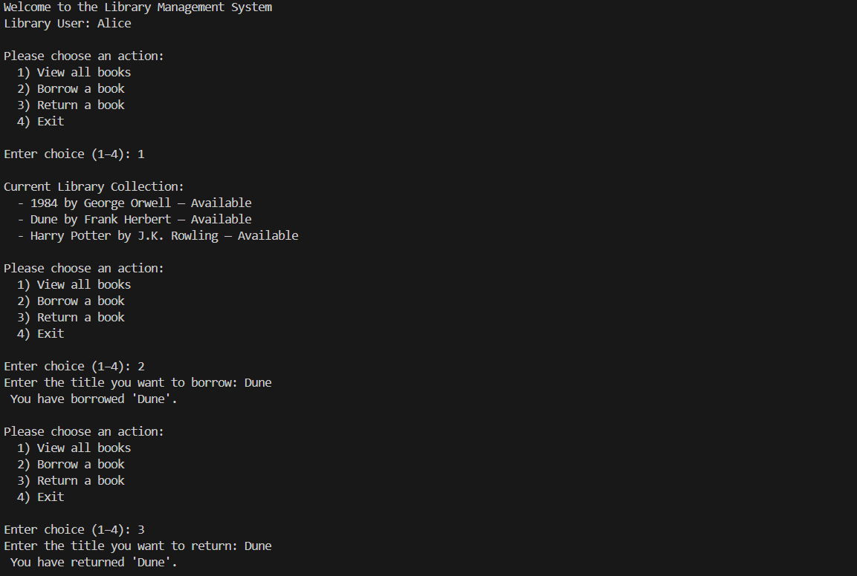

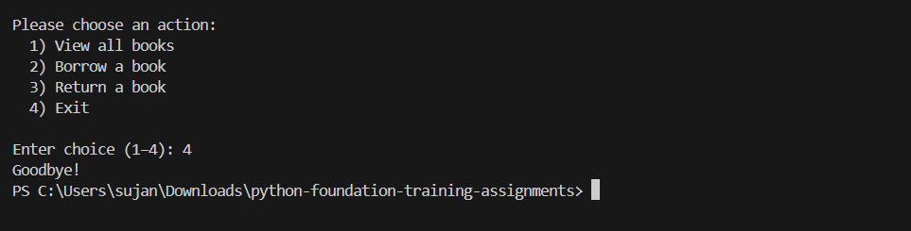

## Section 2: Data Structures & Algorithms (30 mins)

Q3. Algorithm Problem – Minimize Coins (Greedy) (15 mins)  
- Find minimum number of coins needed for a given amount  
- Denominations: [1, 2, 5, 10, 20, 50, 100, 200, 500]

**SOLUTION**

def minimize_coins(amount):

    denominations = [500, 200, 100, 50, 20, 10, 5, 2, 1]

    result = {}

    remaining = amount

    for coin in denominations:

        count = remaining // coin

        if count > 0:

            result[coin] = count

            remaining -= coin * count

    return result

def main():

    amt_str = input("Enter amount (integer) to change: ").strip()

    if not amt_str.isdigit():

        print("Invalid input; please enter a positive integer.")

        return

    amt = int(amt_str)

    if amt <= 0:

        print("Amount must be greater than zero.")

        return

    coins_used = minimize_coins(amt)

    print(f"Minimum coins/notes for Rs.{amt}:")

    for coin, cnt in coins_used.items():

        print(f"  Rs.{coin} x {cnt}")

if __name__ == "__main__":

    main()

**OUTPUT**

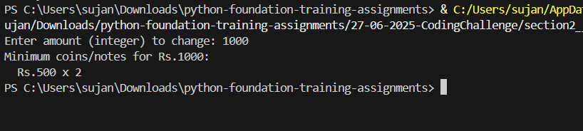

Q4. Data Structure Usage (15 mins)  
- Stack: Evaluate postfix expression '231*+9-'  
- Linked List class: append(), display(), reverse()

**SOLUTION**

def eval_postfix(expr):

    stack = []

    for token in expr:

        if token.isdigit():

            stack.append(int(token))

        else:

            # pop two operands (b then a)

            b = stack.pop()

            a = stack.pop()

            if token == '+':

                stack.append(a + b)

            elif token == '-':

                stack.append(a - b)

            elif token == '*':

                stack.append(a * b)

            elif token == '/':

                stack.append(a // b)

    return stack[0]

# Node class for linked list

class Node:

    def __init__(self, data):

        self.data = data

        self.next = None

# Linked list with append, display, and reverse

class LinkedList:

    def __init__(self):

        self.head = None

    def append(self, data):

        new_node = Node(data)

        if self.head is None:

            self.head = new_node

        else:

            current = self.head

            while current.next:

                current = current.next

            current.next = new_node

    def display(self):

        values = []

        current = self.head

        while current:

            values.append(str(current.data))

            current = current.next

        print(" -> ".join(values))

    def reverse(self):

        prev = None

        current = self.head

        while current:

            nxt = current.next

            current.next = prev

            prev = current

            current = nxt

        self.head = prev

def main():

    # Part a) Evaluate the example '231*+9-'

    expr = "231*+9-"

    result = eval_postfix(expr)

    print(f"Postfix expression {expr} evaluates to: {result}")

    # Part b) Demonstrate linked list

    print("\nCreating linked list with values 1,2,3,4,5")

    ll = LinkedList()

    for i in [1,2,3,4,5]:

        ll.append(i)

    print("Original list:")

    ll.display()

    print("Reversing list...")

    ll.reverse()

    print("Reversed list:")

    ll.display()

if __name__ == "__main__":

    main()

**OUTPUT**

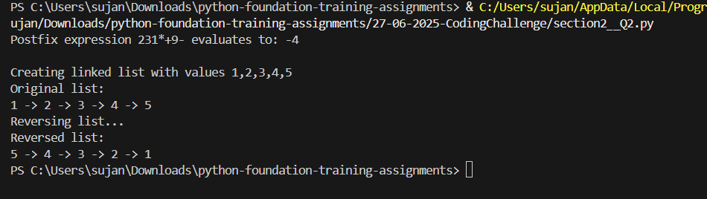

## Section 3: SQL with Python Integration (30 mins)

Q5. SQL + Python – Student Scores Table  
- Create table StudentScores(name VARCHAR, subject VARCHAR, marks INT)  
- Insert sample data  
- Use Python to display records, show average marks, list students scoring <40

**SOLUTION**

import sqlite3

conn = sqlite3.connect(':memory:')

c = conn.cursor()

c.execute("CREATE TABLE StudentScores (name TEXT, subject TEXT, marks INTEGER)")

c.execute("INSERT INTO StudentScores VALUES ('Alice', 'Math', 75)")

c.execute("INSERT INTO StudentScores VALUES ('Bob', 'Science', 55)")

c.execute("INSERT INTO StudentScores VALUES ('Charlie', 'Math', 35)")

c.execute("INSERT INTO StudentScores VALUES ('Daisy', 'English', 82)")

c.execute("INSERT INTO StudentScores VALUES ('Ethan', 'Science', 29)")

c.execute("INSERT INTO StudentScores VALUES ('Fiona', 'Math', 91)")

print("All Students:")

for row in c.execute("SELECT * FROM StudentScores"):

    print(row)

c.execute("SELECT AVG(marks) FROM StudentScores")

avg = c.fetchone()[0]

print("\nAverage Marks:", round(avg, 2))

print("\nStudents scoring below 40:")

for row in c.execute("SELECT * FROM StudentScores WHERE marks < 40"):

    print(row)

conn.close()

**OUTPUT**

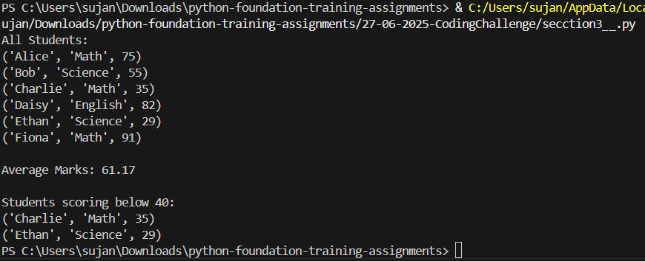

## Section 4: Version Control with Git (10 mins)

Q6. Git Challenge  
- Initialize Git repository  
- Create and switch to branch feature/students  
- Add and commit your Python code  
- Merge feature/students into main  
- Provide Git commands

# 1. (If you haven’t already) initialize the repo

git init

# 2. Create & switch to the feature branch

git checkout -b feature/students

# 3. Stage and commit your Python code

git add .

git commit -m "Add all Python solutions and tests for student challenge"

# 4. Switch back to main and merge the feature branch

git checkout main

git merge feature/students

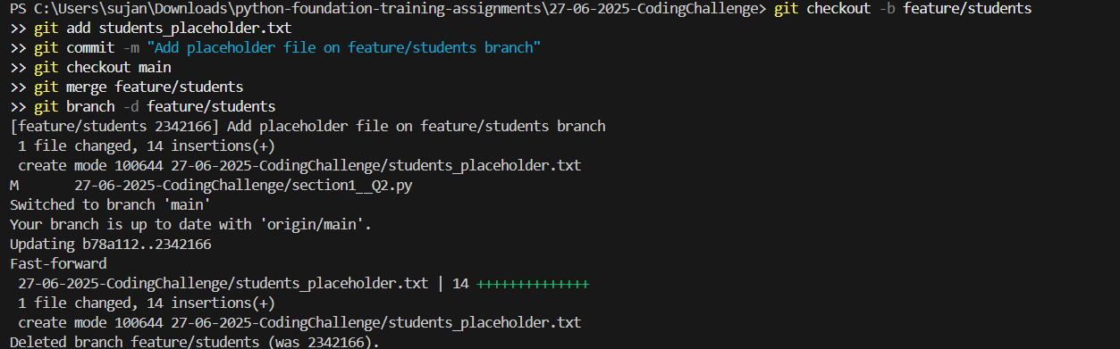

## Bonus Section: PyUnit Test Case (10 mins)

Q7. PyUnit test cases for Q1 (Booking System)  
- 1 test case for calculate_amount()  
- 1 test case for booking() using mocks if needed  
- Use unittest.TestCase, setUp(), tearDown()

**OUTPUT**

import unittest

from io import StringIO

import sys

# Import the functions from your section1q1 script

import section1__Q1

class TestMovieBooking(unittest.TestCase):

    def test_calculate_amount(self):

        # Test known prices

        self.assertEqual(section1__Q1.calculate_amount("Avengers", 3), 250 * 3)

        self.assertEqual(section1__Q1.calculate_amount("Parasite", 2), 150 * 2)

        # Unknown movie should cost 0

        self.assertEqual(section1__Q1.calculate_amount("Unknown", 5), 0)

    def test_booking_flow_valid(self):

        # Simulate user input: pick movie 1 (Avengers), then 2 tickets

        inputs = ["1", "2"]

        # Capture stdout

        backup_stdout = sys.stdout

        sys.stdout = StringIO()

        # Monkey-patch input()

        backup_input = __builtins__.input

        __builtins__.input = lambda prompt="": inputs.pop(0)

        try:

            section1__Q1.book_tickets()

            output = sys.stdout.getvalue()

        finally:

            # Restore

            sys.stdout = backup_stdout

            __builtins__.input = backup_input

        # Check that the output mentions the correct booking and total

        self.assertIn("booked 2 ticket", output)

        self.assertIn("Total amount: Rs.500", output)

    def test_booking_flow_invalid_movie(self):

        # Non-numeric movie choice should abort early

        inputs = ["x"]

        backup_stdout = sys.stdout

        sys.stdout = StringIO()

        backup_input = __builtins__.input

        __builtins__.input = lambda prompt="": inputs.pop(0)

        try:

            section1__Q1.book_tickets()

            output = sys.stdout.getvalue()

        finally:

            sys.stdout = backup_stdout

            __builtins__.input = backup_input

        self.assertIn("Invalid input", output)

    def test_booking_flow_invalid_qty(self):

        # Valid movie choice, then invalid ticket count

        inputs = ["2", "-3"]

        backup_stdout = sys.stdout

        sys.stdout = StringIO()

        backup_input = __builtins__.input

        __builtins__.input = lambda prompt="": inputs.pop(0)

        try:

            section1__Q1.book_tickets()

            output = sys.stdout.getvalue()

        finally:

            sys.stdout = backup_stdout

            __builtins__.input = backup_input

        self.assertIn("Invalid input", output)

if __name__ == "__main__":

    unittest.main()

**OUTPUT**

